**Ideation Phase**

**Brainstorm& Idea Prioritization Template:**

|  |  |
| --- | --- |
| Date | 27june2025 |
| Team ID | LTVIP2025TMID60006 |
| Project Name | CitizenAi-intelligentcitizenengagementplatform |
| Maximum Marks |  |

**Brainstorm&IdeaPrioritizationTemplate:**

Citizen AI Intelligent Citizen Engagement Platform: Idea Generation & Prioritization Just as traditionalbrainstormingfostersanopenenvironmentforcreativeproblem-solving,aCitizen AIIntelligentCitizenEngagementPlatformprovidesadynamicspacewhereeverycitizencan actively participate in shaping their community. This platform encourages the free flow of ideas, prioritizing the volume of diverse input over initial perceived value. Out-of-the-box suggestions are welcomed and, through the power of AI, can be built upon and refined. The platform facilitates collaboration, allowing citizens and AIto work together to develop a rich array of creative solutions for civic challenges.

**Step-1:TeamGathering,CollaborationandSelecttheProblemStatement**

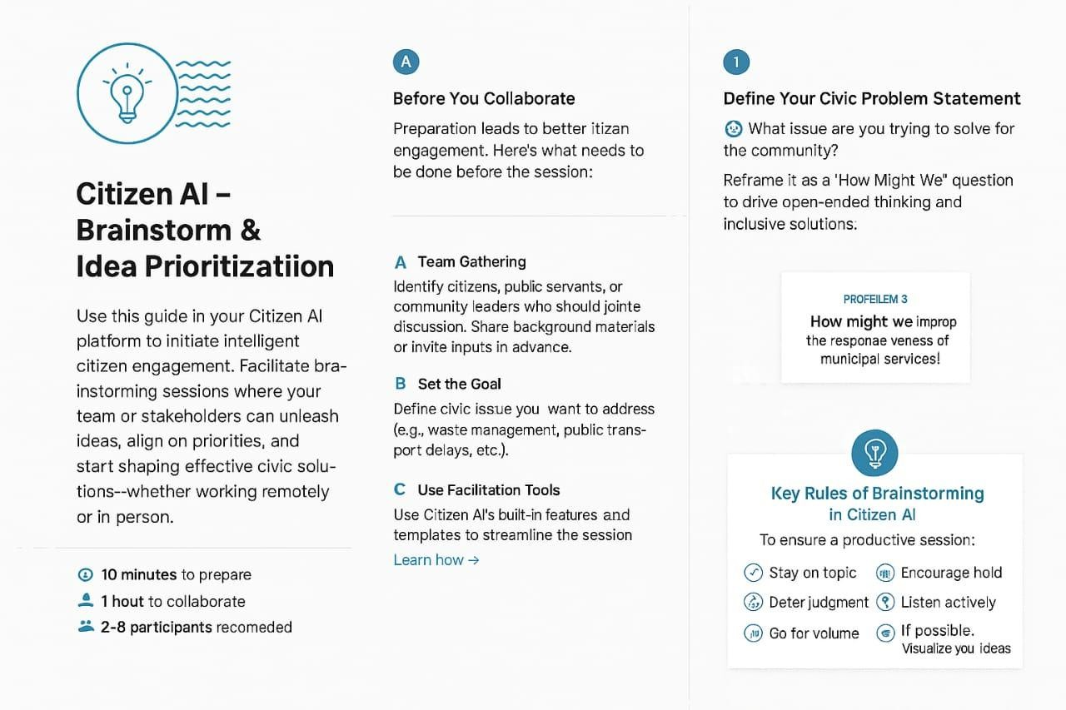

**Step-2:Brainstorm,IdeaListingandGrouping**

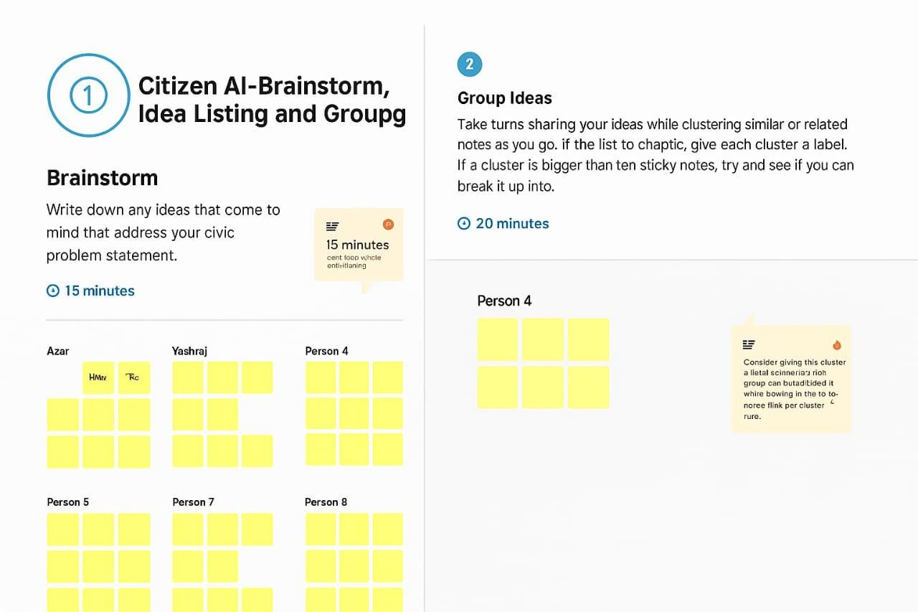

**Step-3:Idea Prioritization**

